AUDIOVISUAL BANKS : HOW TO IMPROVE THE STANDARD OF THE CATALOGUE WITHOUT KNOWLEDGE IN NEW TECHNOLOGY?
The work of the staff of the Programme Banks of Television and Radio.

By Tedd Urnes

THE AIM

The aim of the lecture is to give those of you who are working with catalogues some ideas about how to improve the standard of the catalogues without detailed information about
digital technology or information about any other sofisticated working tools for the documentalists or audiovisual librarians.

The purpose of the presentaion is to focus on content description of televison programmes and radio programmes and movies in order to make it possible to find the material wanted years after the programmes have been transmitted. Due to the fact that the word “ archive “ has been evaluated as a passive word for years or a concept that appeals to negative attitudes among people, the concept: “ Bank “ will replace the word “ Archvie “ in this presentation.
We will be talking about banking in the future – not archiving any more.

THE BANK – INVESTMENT - KNOWLEDGE – CONTENT

Correct content description of television and radio productions and movies is not an easy task.
The challenge is the selection of information wanted for future research. What do we need to know to find the programmes and excerpts of the productions 30 years after the transmittion of the programmes? With reference to my own experience working for the Film and Television Bank of the Norwegain Broadcasting Corporation for about 25 years, there is no final answer to the question. The issue is an ever lasting subject for evaluations and critics among the users of the bank and the producers who make the products.

The work mentioned is also a challenge to those who are going to make the content description of programmes made without their assistance or cooporation. The situation for the audiovisual librarian is not easy. The annual productions of television and radio companies worldwide are not limited to some subjects only. On the contrary – the productions are a picture of what is going on in your country and worldwide. We all know the situation.

EDUCATION - EXPERIENCE

A degree in librarianship or a university degree is not enough.- but a good start for your work. The main issue is knowledge about the programmes produced or information about future products. You do not need to be an expert in architecture or house building to manage to write a good description of content of progammes mentioned. But you need to be interested in the matter. You have to approach any subject with enthusiasm and a childish curiosity to make a description of the events of the progamme accessible 30 years after you have done the work.

CONTENT – PROGRAMME: REPORT FROM BALTICUM

Let us make an experiment. A Norwegian programme about Latvia will be presented to you.
The programme was transmitted in Norway September 17, 1987. The title of the programme is: Rapport fra Baltikum. The duration of the programme is about 15 minutes. We view the programme. Then we up-date the information of the content description with reference to information available on internet and information based upon your own experience. It is important to know and to up-date information about the following persons who participate in the programme:

Maris Caklais
Aleksander Emeljanov
Juris Ziemelis
Nikolaj Neiland
Arians Alkins
Kostad Mejdunas
Ceslovas Jursenas

What do we need to know about the persons mentioned? Is the spelling of the names correct?
What is their position in society in 1987 and what have happened to the persons? What about the statements they make? Do you agree with the statements or should you add some comments to correct the statements?
Why are these questions so important? The main reasons for correct information are the wish to reuse excerpts of the programme in new programmes. A portrait of the persons could also be made later on.

The shots of Riga are made in 1987. Do you know the shots or are there changes of the city fra 1987 till 2004? What part of Riga is shown here? A memorial monument is shown,. Have you seen the monument and what is the name of the historical site? Is the monument still to be found in the city of Riga? The questions must be asked to improve the data of the programme.

The programme present different equipments for fighting. Do you think we should describe the tools presented? Fighting gloves for street fighting in close up?
Finally – how do you want to classify the programme with reference to the use of a subject catalogue? Or do you use the Dewey Classification System to classify the different subjects
by using numbers?

When we have answered all the questions, let us view the programme again to see if we have forgotten facts important for the catalogue and important for those who will use the catalogue in 30 years from now on.

CONTENT- PROGRAMME: RIGA: ØSTERSJØEN – “ FREDENS HAV “

Let us also evaluate and view another Norwegian programme with focus on the description of the events and persons presented in the programme. The year is 1983. The programme was transmitted in April 26, 1983 in the daily television news. The reporter is Hans-Fredrik Steinfeld who is famous in Norway and also in East -Europe. Hans-Fredrik Steinfeld has written books about the political and social development of the countries in East- Europe.
He speaks Russian. The duration of the programme is about 7 minutes only.
The city is Riga. The story is about the official foreign policy of Sovjet- Union in the year 1983. About 21 years ago. Some of you attending the seminar were not yet born. We are wieving history alive so to speak. Please take a look at the different shots and let us talk about the following subjects:

Sweden: A Russian Submarine on the coast of Sweden , Karlskrona October 1981.

The city of Riga in 1983
The Russian Navy
NATO and Latvia
An orchestra – a popband
The Peace committee of Latvia
Buildings in Riga
Andris Vejans
Viktor Ozolynskij

We must evaluate the programme thinking about the value in reusing the different scenes of the programme. Questions need to be asked. What kind of Russian submarine is presented in the story? The name of the boat – W-137 (Whisky class) ? What type of submarine is this? What kind of weapons were submarine equipped with? Did the Russian Submarine carry nuclear weapons? And think about the programmes where the shots of the boat were to used in the future? The name of the site in Sweden where the boat went ashore? Karlskrona?
Who is Andris Vejans? Any information about him on internet? What about Viktor Ozolynskij? Any of you who have heard the names before? The popband is playing a song called in German: “ Ein bischen Frieden “ and is it possible to connect the song to the annual European Broadcasting competition about the best song of the year?
The students who are making statements are not students anymore. It might be a possiblity that some of them are working for the government or are active in the poltical life of Latvia?
Who knows? The shots were made about 21 years ago.

The appoarch of the documentalist, the librarian , the archivist or the new banker must be done in an unemotional way. We must not get personnaly involved in the main issue of the story and make a political decision. No. On the contrary – you approach the audiovisual history in a humble way thinking about the value in making new programmes. You must develop a methode for pratical reusing of the scenes for new radio and television productions and also for future history studies. The written word is not the only source for university studies any more. Due to the introduction of Legat Depost law of audiovisual productions in Sweden, Norway and Denmark , the researchers might evaluate the political and social events with assistance of radio and television programmes transmitted.

CONCLUSION

The aim of this presentation is to make you aware of the many possiblities of reusing old and forgotten radio and televison productions. Without a good content description of the production the reusing will not be possible. The new digital technology is a must for most audiovisual banks in the future. Anyway the basic knowledge of content description of programmes will remain important. The challenge for “ Banker “ is to show an interest in the collections stored or as we have announced – an interest in the new bank of programmes.
I have paid a visit to many old libraries worldwide. Take a look at photos from Mexico,
The Island of Mallorca and Italy taken by me during the visits. I am happy that no selection policy was intruduced to these historical collections. What would have been left of the collections? How to reuse the books in year 2004? Not easy due to lack of catalogues and lack of information about the content of the books. Do we want this situation to be topical in 400 years when people want to use radio and television programmes for educational purposes or for making new production? You tell me fellow students.
Thank you for you attention.

Tedd Urnes,
Senior Adviser, Norwegian Broadcasting Corporation (NRK)

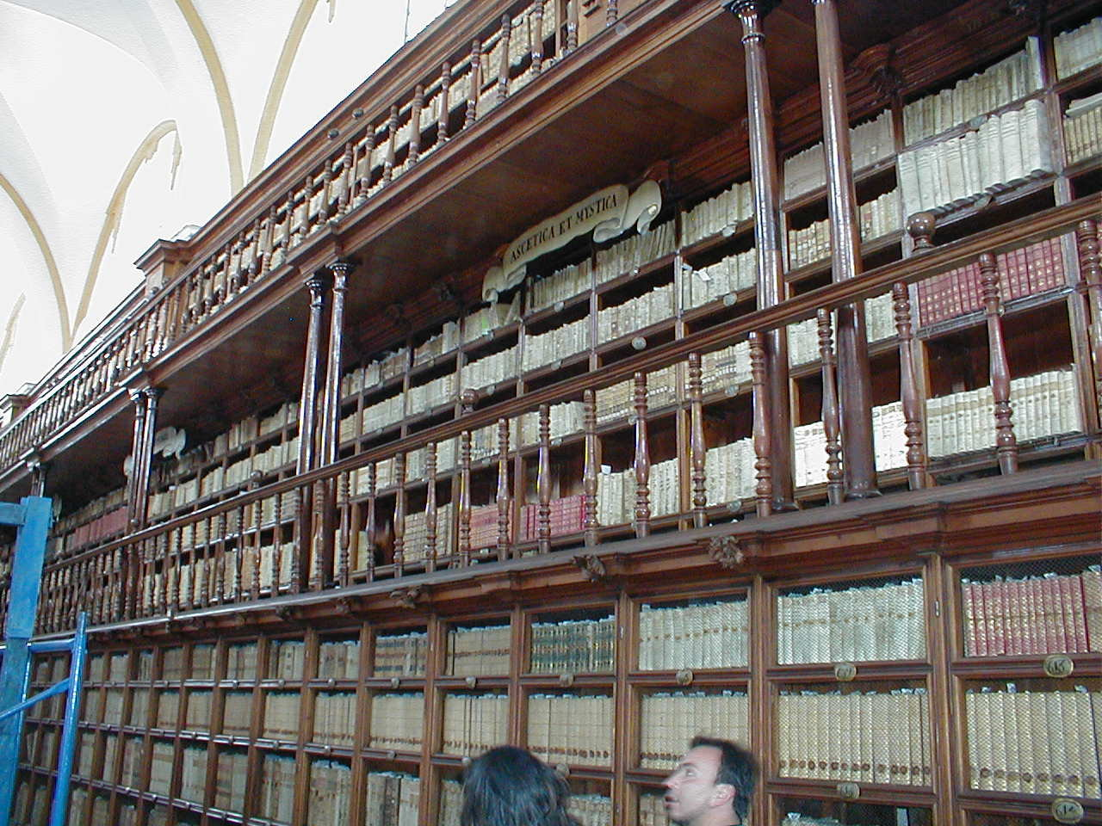

Photo: Tedd Urnes, 2003

Mexico: La Biblioteca Palafoxiana ( The Palafoxiana Library) in Puebla.
41.582 volumes about theology, philosophy, holly words and doctrine.
What about the content descriptions of the collection published from the
year 1493 till about 1822? What about an access policy for the library?

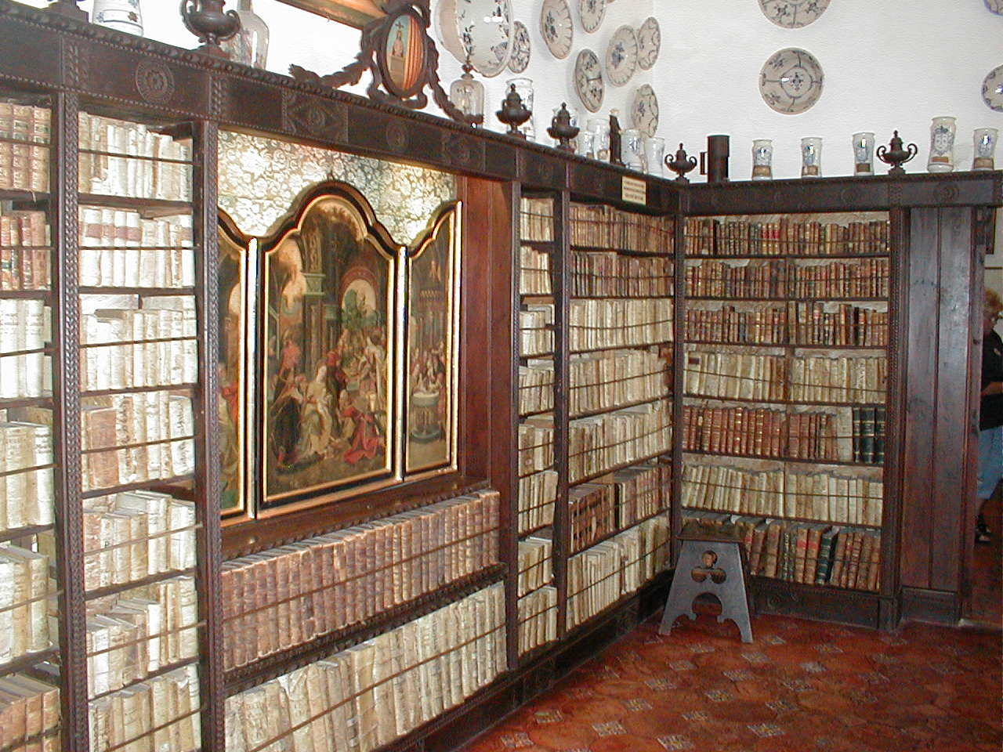

Photo: Tedd Urnes, 2004

Mallorca: Valldemossa. The Library of the Carthusian Monastery dating back to 1399.
The monastery was closed in 1835. The library is famous because George Sand and Frederic
Chopin used the library during the winter of 1838 –39.
How to reuse the collection to-day and what about a description of the contents of the book?
What about the access policy of the audiovisual libraries worldwide in year 2004 and in 400
Years from now on?

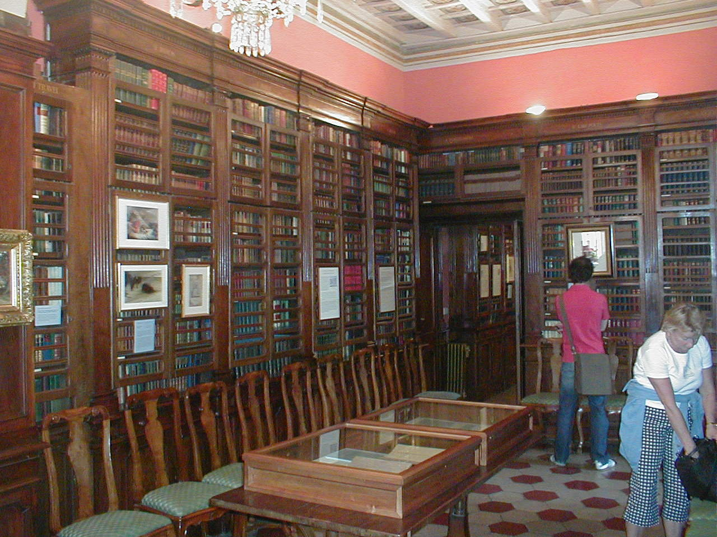

Italy.Rome: The Shelly Library situated close to The Spanish Stairs in Rome in year 2004.
Photo: Tedd Urnes

